CSS 311 - Parallel and Distributed Computing

Title: Parallel Implementation of Traffic Accident Analysis

Name 1: Allu Pranathi Roll No: 2023BCD0065
Name 2: Kavala Sai Sri Neharika Roll No: 2023BCD0053

Course Instructor: Dr. John Paul Martin
Department of Computer Science, Indian Institute of Information Technology Kottayam (IIIT Kottayam)

Date of Submission: 11/10/2025

Abstract

Our Project “Parallel Traffic Accident Analysis” mainly focuses on processing and analyzing large datasets which contain the accident details such as accident cause, severity, weather conditions and traffic density.

In serial Implementation, first it reads a csv file (our dataset) and processes each record sequentially to get the results like total injuries, fatalities, frequency of causes and conditions, etc. But this approach takes a lot of time for analyzing large real-world datasets because it is following sequential analysis.

To solve this issue, we developed an OpenMP based parallel version. So, basically we will divide the accident records among multiple threads, where each thread can be independently compute sum for total injuries, fatalities, frequency of conditions, etc. And these sums are merged to global sum using race condition handling techniques.

Our Serial Implementation takes “0.622 sec“ time for analysis. And the parallel version takes “0.13 sec” for analysis. This indicates the parallel version is 4.7 times faster than serial.

1.Introduction

As we know now a days the number of motor vehicles are increasing,which leads to traffic becoming severe.It is estimated that over half of the traffic crowd is caused by Incidents such as accidents,construction and maintenance activities,weather conditions.Traffic accidents are a primary concern for the public, because it causes major loss of human lives and economy.

To reduce the accidents we will take a dataset of previous accidents which gives information about the accidents like how many accidents happened in a particular month (or) place.Usually it takes more execution time without parallelising because the data size is large.

Parallel and distributed computing gives an efficient solution by dividing the work with multiple threads which reduce the execution time which makes the work easier.This project gives information about basic statistics i.e total accidents ,injuries average vehicles per accident and Key Distributions like severity ,accident cause ,traffic density ,which will reduce the accident rate.

This “Parallel Traffic Accident Analysis” can directly fits into Real-world Transportation systems and public safety applications. Analyzing this data can helps in identifying high risk zones and understanding the major causes of accidents. Which is very helpful in day-to-day life.

2. Literature Survey

Here we are referring to the previous work thesis “Freeway Accident analysis using Second order Statistics”.
(We provided this thesis link in the reference section).

Summary of the thesis:

In this thesis, the freeway accident data is analyzed using a serial (sequential) approach. They started the process with collecting accident and traffic information like speed, volume, etc from a SQL server database. This collected data is then manually extracted and processed for each accident separately.

Next, a Visual Basic(VB) program was used to calculate the 3 second-order statistical measures (Angular Second Moment (ASM), Contrast and Entropy). These 3 statistical measures describe the smoothness, randomness and variation in traffic patterns before and during an accident.

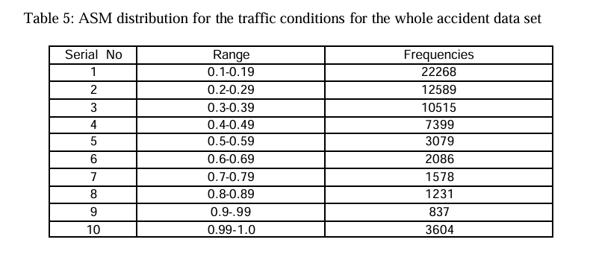

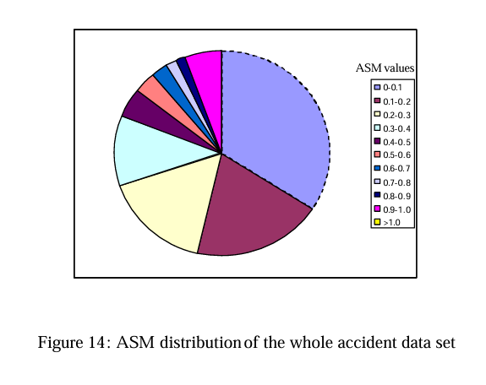
But these calculations are done sequentially, means only one accident record is processed at a time.

After this, all these results are stored in an Excel file called “Run-On File”.
This excel file contains time, station, accident number, ASM, contrast, and entropy, Group (0 or 1).

Group 0: Accident occurrence condition traffic speed contour maps could
be created.
Group 1: Precursory traffic condition traffic speed contour maps could be
created.

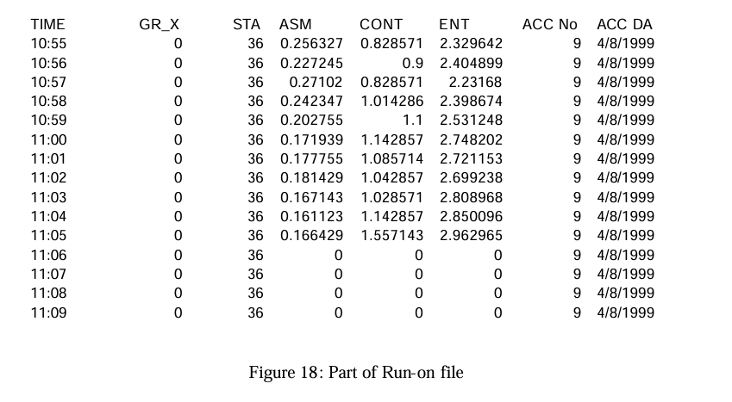

Limitations of this sequential approach:

- Processing one accident at a time makes the program slow.
- Here, the collected data is manually extracted. So, it depends on the person’s knowledge for getting a better result.
- This sequential method is not that helpful for large datasets or multiple locations.

3. Problem Statement and Objectives

3.1 Problem Definition

The computational problem solved in this project is the efficient analysis of large traffic accident datasets to extract meaningful statistical details like accident frequency, severity distribution etc.

In serial Implementation, the project takes the data file as input which contains details about accident cause ,traffic density ,number of deaths from the particular accident ,weather and road condition, etc. With the given data it will give the total number of accidents ,injuries that happened. It will also give the peak time when more accidents are happening.
This is processed record by record.

So, The computational challenge is to:
Implement and design an efficient “parallelized traffic accident analysis” so that it can process large datasets using multi-core CPU like OpenMP for faster execution.

3.2 Objectives

- To collect traffic accident dataset for analysis.
- Implement serial code to give the estimation of accidents at particular time and place.
- Similarly implement parallel execution to give the estimation of accidents at particular time and place.
- Compare the performance of both serial and parallel implementations.
- To evaluate scalability and efficiency with different dataset sizes.

4. Methodology and System Architecture

Workflow:

Dataset Description:

For this project, we created our own dataset “india_traffic_accidents.csv” containing 10 lakh accident records which is exactly similar to real world accident datasets.
(Because, the available real world datasets from kaggle are too large (the file sizes are approximately 5 to 6 GB))

Our dataset Columns description:
- id: Unique accident number
- date: Date of the accident (YYYY-MM-DD)
- time: Time of the accident (HH:MM)
- latitude / longitude: Geographic coordinates of the accident location
- severity: Accident severity level (e.g., minor, major, fatal)
- road_condition: State of the road (e.g., dry, wet, icy, potholes)
- weather: Weather during the accident (e.g., clear, rain, fog)
- vehicles_involved: Number of vehicles in the accident
- injuries: Number of non-fatal injuries
- fatalities: Number of deaths resulting from the accident
- accident_cause: Primary cause (e.g., speeding, distraction, poor visibility)
- traffic_density: Level of traffic flow (e.g., low, medium, high)
- lane_utilization: Measure of congestion per lane
- nearby_accidents: count of nearest accidents

Implementation Process:

For serial:

We started our implementation by reading the dataset “india_traffic_accidents.csv”. This reading is done with the readData() function.
This function opens the file and it skips the header and reads all the records one by one.

During reading, csv file is comma separated so it separates the data by commas and removes extra spaces and it converts the text data into numbers wherever there is needed (like for vehicles, fatalities and injuries.)
(Because in csv files all variables are stored as string).

Each accident record is now stored in a structure Accident. And all these records are stored in a vector. (vector<Accident>)

After the data is loaded, we move to the Analysis phase. The analyze() function processes this data to calculate important statistics like total injuries, fatalities and the average number of vehicles per accident.
It also counts how many accidents occurred under different conditions like severity, weather, cause, traffic density.
For peak accident hour, from the dataset it extracts the time column and identifies which hour has more accidents.
Finally, we provided an interactive mode for the user, to enter the dataset file to calculate all these results for the user provided data.

For parallel:

For parallel implementation, we just modified mainly the analyze() function.
This function divides the computation of results among multiple threads. Each thread processes a portion of accident records and these threads maintain their own local variables to get totals for injuries, fatalities, vehicles, nearby accidents, and hourly counts.
Now, these results are combined into global totals using atomic. (#pragma omp atomic)

And for categorical data like severity, accident cause, traffic density, weather conditions, each thread maintains their own local unordered maps (local_sev, local_cause…) to count them.
After this, these are merged to global maps (sevCount, causeCount..). The (nearby_accident > 20) means high cluster zone is calculated using #pragma omp reduction.
Flowchart For Serial Implementation:

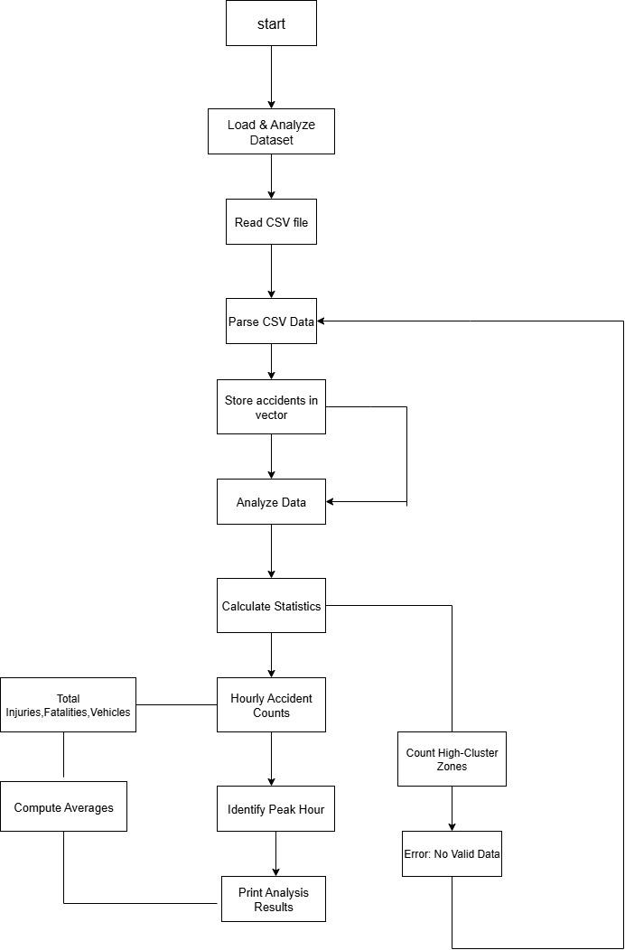

Flowchart for Parallel Implementation:
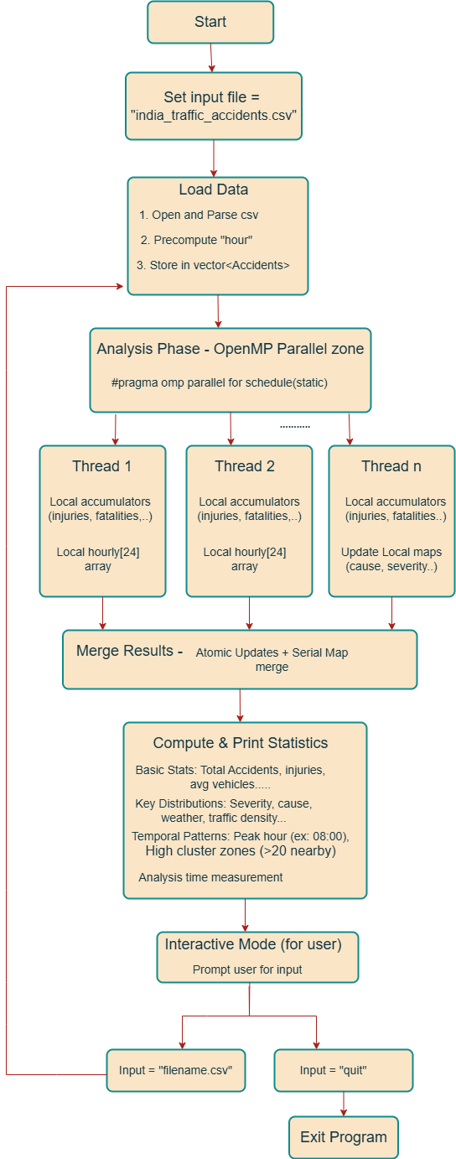
4.1. Serial Algorithm

BEGIN
STRUCT Accident(id, veh, inj, fat, near, lat, lon, date, time, sev, road, weather, cause, traffic, lane)

FUNC trim(s) → s without spaces
FUNC extractHour(t) → int(before ":") IF valid ELSE -1

FUNC readData(f)
OPEN f; IF fail RETURN []
SKIP header; data=[]
FOR each line
tokens = trimmed CSV split
IF len=15 THEN ADD Accident(tokens)
RETURN data

FUNC analyze(L)
INIT totals=0s, maps={}, hourly[24]=0
FOR a IN L
UPDATE totals, maps[a fields]; h=extractHour(a.time); IF h≥0 THEN hourly[h]++
PRINT stats, maps, "Peak hour", argmax(hourly), "Clusters", count(a.near>20)

MAIN
PRINT student info
data=readData("india_traffic_accidents.csv")
IF data EMPTY PRINT "No data" ELSE analyze(data)
LOOP
ASK "File (or quit):"; READ f
IF f="quit" BREAK
d=readData(f); IF d EMPTY PRINT "No valid data" ELSE analyze(d)
PRINT "Exit."
END

4.2. Parallel Algorithm (OpenMP)

BEGIN

FUNCTION readData(filename):
OPEN CSV file
SKIP header
FOR each line in file:
PARSE columns
CREATE Accident record (extract hour, convert to numeric)
APPEND to data list
RETURN data list

FUNCTION analyze(accidents):
n -> number of accidents
INIT totals: total_inj, total_fat, total_veh, total_nearby = 0
INIT hourly[24] = 0

#pragma omp parallel
{
local_inj, local_fat, local_veh, local_nearby = 0
local_hourly[24] = 0

#pragma omp for schedule(static)
FOR i in 0..n-1:
ACCUMULATE local values (injuries, fatalities, etc.)
INCREMENT local_hourly[hour]

#pragma omp atomic
total_inj += local_inj
#pragma omp atomic
total_fat += local_fat
#pragma omp atomic
total_veh += local_veh
#pragma omp atomic
total_nearby += local_nearby

FOR h in 0..23:
IF local_hourly[h] > 0 THEN
#pragma omp atomic
hourly[h] += local_hourly[h]
}

num_threads ← omp_get_max_threads()
CREATE local maps per thread: severity, cause, traffic, weather

#pragma omp parallel
{
tid ← omp_get_thread_num()
#pragma omp for schedule(static)
FOR i in 0..n-1:
UPDATE local maps[tid] with accident string fields
}

MERGE all thread-local maps into global maps

COMPUTE averages, peak hour
PRINT statistics and distributions

high_cluster = 0
#pragma omp parallel for reduction(+ : high_cluster)
FOR i in 0..n-1:
IF nearby_accidents > 20:
high_cluster++

PRINT high_cluster result
END FUNCTION

MAIN:
LOAD original dataset → readData()
CALL analyze(accidents)
LOOP:
ASK user for new CSV filename
IF filename == 'quit' THEN EXIT LOOP
LOAD dataset
CALL analyze(accidents)
END LOOP

PRINT "Exiting program"

END

4.3. Implementation Details

Programming Language: C++

Platform: Windows

Compiler: GCC (-fopenmp)

Hardware Configuration: CPU: Dual-core (2 threads) minimum
Quad-core or higher is recommended

RAM: 2GB minimum
8GB or more is recommended

Storage: HDD (for small datasets)
SSD (for faster I/O on large datasets)

OS: 64 bit

5. Results and Analysis

Output for Serial Implementation:
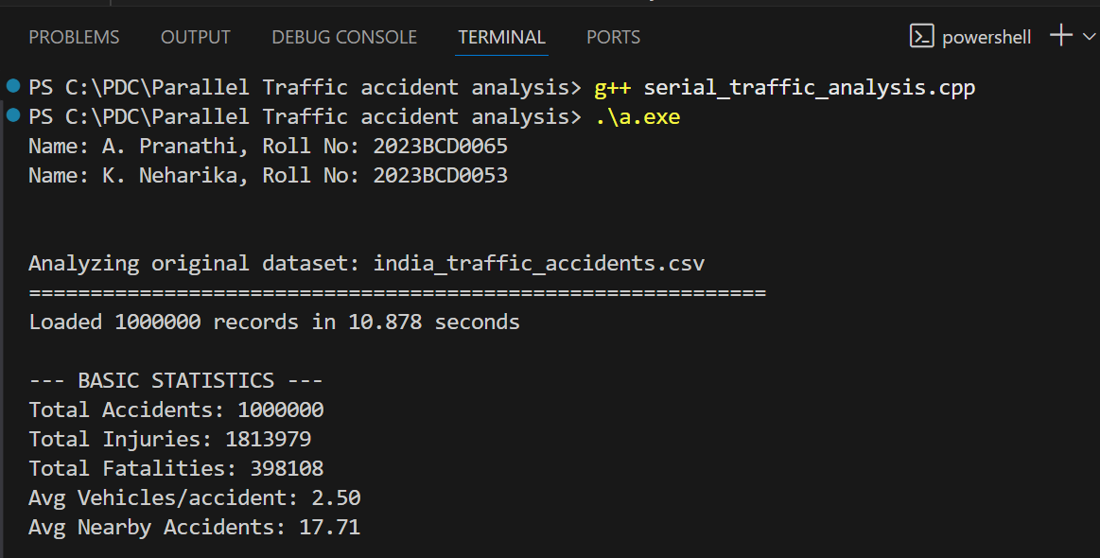
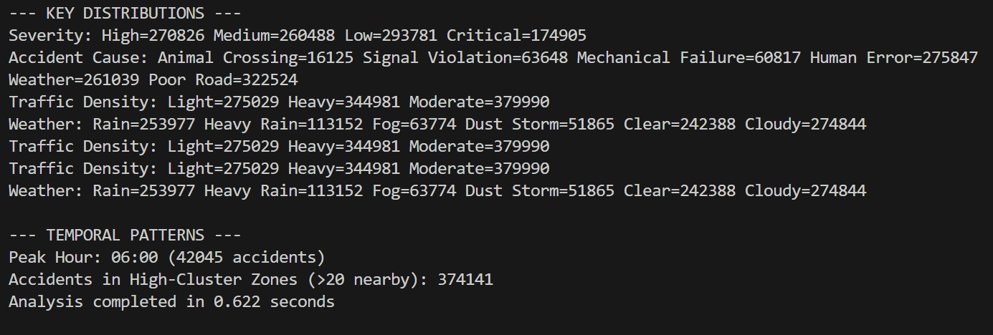
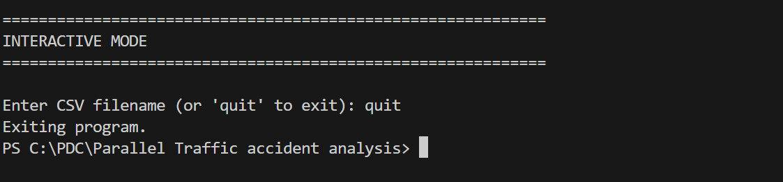

Test case-1: (with 7000 records)

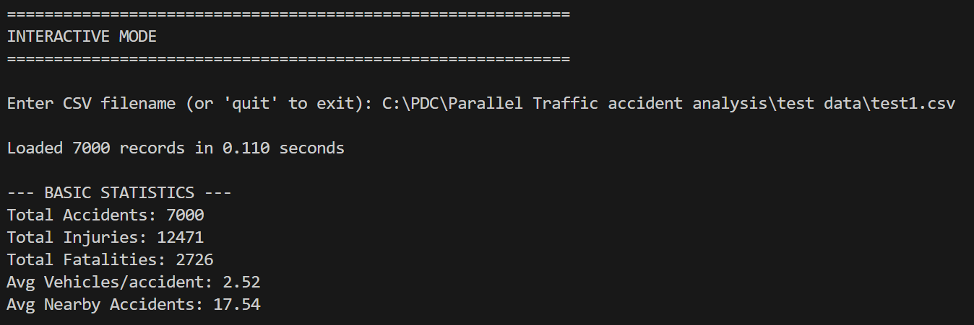
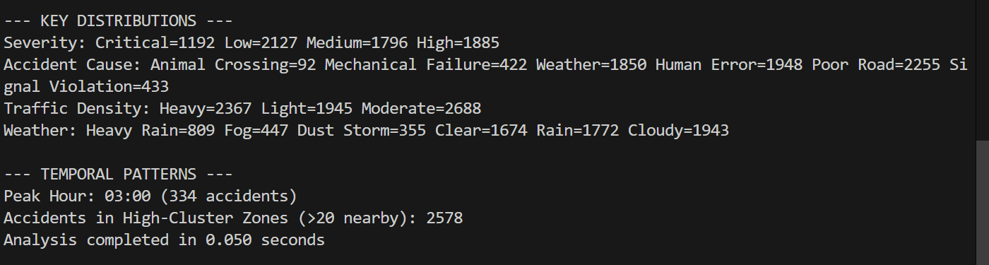

Test case-2: (with 50000 records)

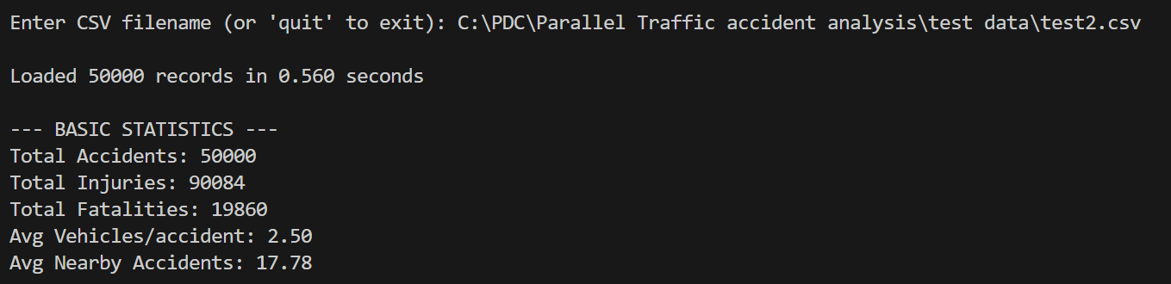
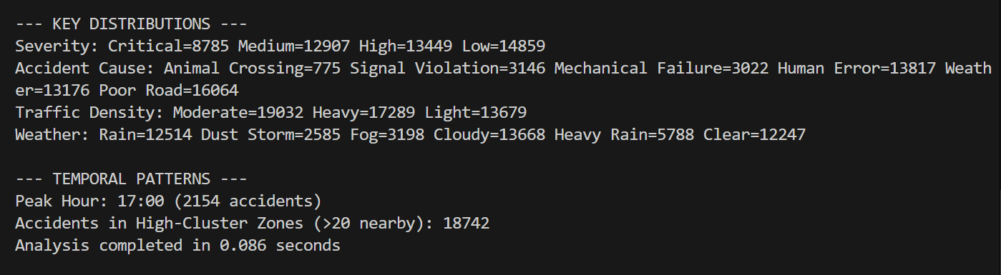

Test case-3: (with 100000 records)

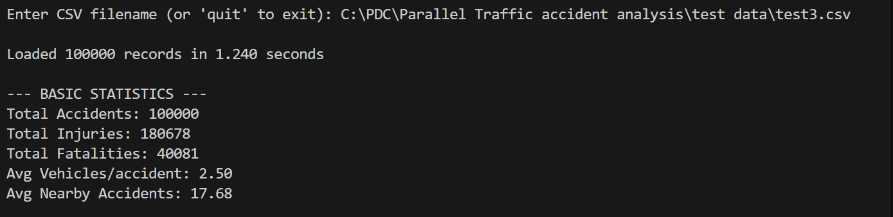
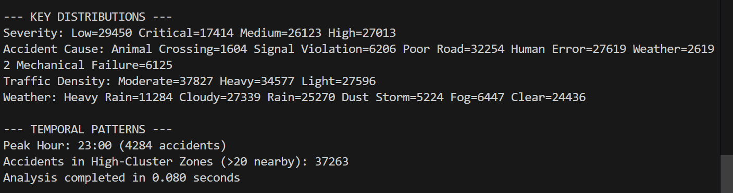

Output for Parallel Implementation:
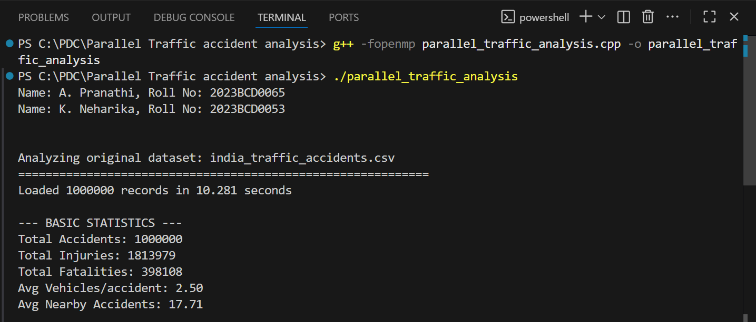
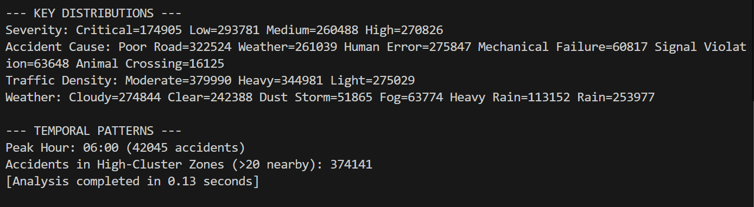
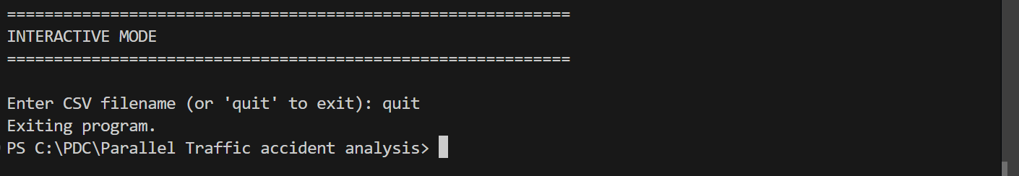

Test case-1: (with 7000 records)

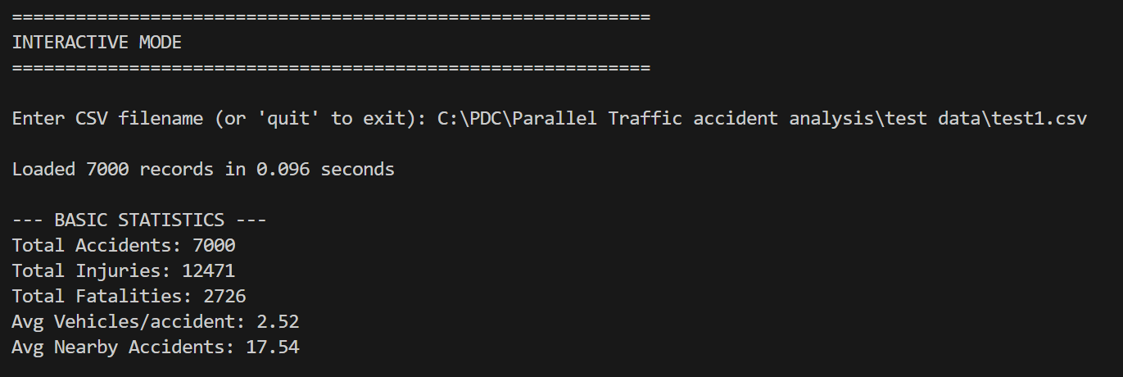
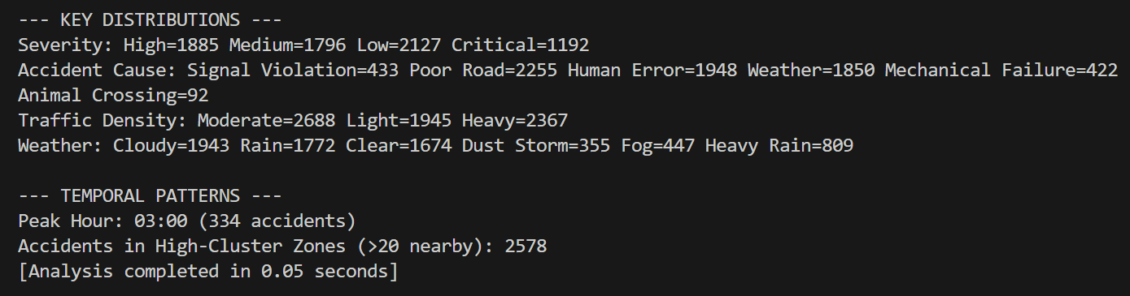

Test case-2: (with 50000 records)

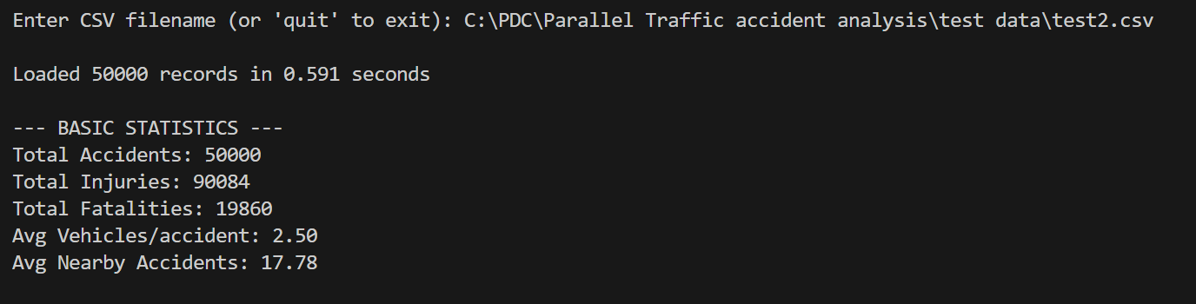
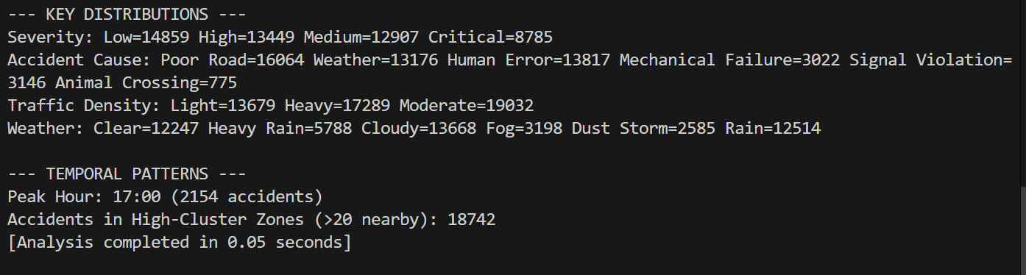

Test case-3: (with 100000 records)

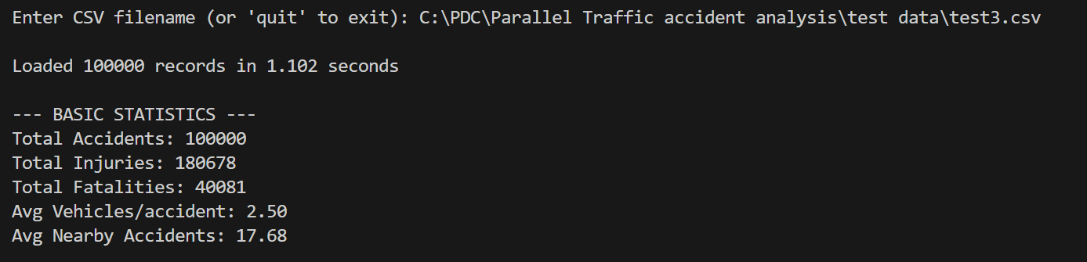
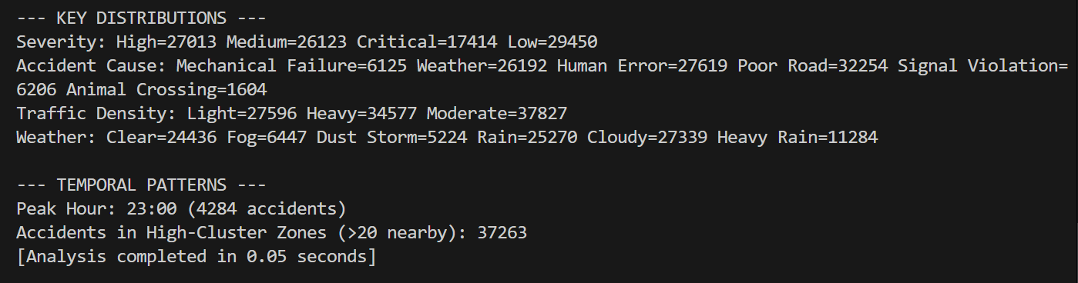

Performance Comparison Table:

Dataset | Serial Time | Parallel Time | SpeedUp
Original dataset | 0.622 sec | 0.13 sec | 4.7846x
Test case-1 | 0.050 sec | 0.05 sec | 1x
Test case-2 | 0.086 sec | 0.05 sec | 1.72x
Test case-3 | 0.080 sec | 0.05 sec | 1.6x
Time Complexity:

Serial Version:
Each accident is read and processed independently → O(N)
N = number of accident records.

Parallel Version:
In this parallel version,computation is divided among threads →O(N/p)

Batch processing(M datasets):

Total complexity ~~ O(M × N / p)

Scalability:

Using OpenMP makes the program much faster because it divides the work along multiple CPU cores parallely at the same time.

So, if the dataset is large, it uses more threads to compute. This makes our program more efficient and runs faster.
Because each accident data record is analyzed separately by each thread.
These threads handle different parts of data without waiting for each other.
So, better scalability can be seen for larger datasets.

Here, there is a small delay from creating and managing threads or reading files. But this delay is very small compared to the total work.

6. Discussion and Observations

This implementation tells about the difference of execution time between serial and parallel. When using OpenMp parallelization . If you take a dataset the serial execution time was 0.622 seconds. While in parallel, it completed in 0.13 seconds,acquiring a speedup of 4.7846x.
We can observe even better speedup for large datasets.

This shows how the work will be completed earlier by parallel version compared to serial version.

Limitations:

The parallel version is better than the serial version,but there are some limitations.The file (CSV) input/output remains sequential operation,as reading and processing from large datasets cannot be parallelized easily .

Load imbalance may occur if data is not distributed uniformly ,meaning some threads finish early while others are still processing the data which reduces the overall parallel efficiency .

7. Conclusion and Future Scope

Work done:

We developed a C++ program to analyze traffic accident data from CSV files. This program computes the key statistics like injuries, fatalities, severity distributions, peak accident hours and high cluster zones.

We improved this implementation by using OpenMP to parallelize adding up numbers, counting text based categories using separate maps for each thread.
These changes make our program run much faster compared to the serial version.

Improvements:

- Our serial program analyzed the data containing (10 lakh records) in 0.622 sec. And the parallel program takes 0.13 sec.
This tells us the parallel version is almost 5 times better than the serial version.
- When counting the categorical data, we used separate maps for each thread. This avoided conflicts.
- We also used atomic operations for calculating totals shared between the threads. It updated correctly without slowing things down.
- Even with all these, the program still processes the data in linear time O(N). And it also scales well for large datasets.

Potential Extensions:

MPI:

For large datasets, the program can be run on multiple computers using MPI.
Each computer can work on its own portion of data without depending on each other.
So, after processing from all computers, we can combine them to get the total sum or count.

Finally, this approach is best for too large datasets (like world-wide accident records) that are difficult to fit in one computer.

CUDA (GPU acceleration):

In our program, tasks that are done independently like counting, filtering and calculating hourly totals, can run on a GPU for faster processing.

The operations like summing values, making histograms for hours, severity etc., can be performed efficiently using libraries like Thrust or cuDF.

This approach is best for large datasets with billions of data, where GPU’s fast memory and multiple cores can be fully used.

8. References

- Freeway accident analysis using second order statistics by LSU Scholarly Repository
https://repository.lsu.edu/cgi/viewcontent.cgi?article=1318&context=gradschool_theses

- Analysis of traffic accident characteristics and recovery strategy of urban road network. (Article)
https://jeas.springeropen.com/articles/10.1186/s44147-025-00657-1

- Analysis of traffic accidents based on Spark and casual inference
https://www.ewadirect.com/proceedings/ace/article/view/14882/pdf

Appendix

- Serial Code:

#include <iostream>
#include <fstream>
#include <vector>
#include <string>
#include <sstream>
#include <unordered_map>
#include <algorithm>
#include <iomanip>
#include <chrono>
using namespace std;

struct Accident
{
int id, vehicles, injuries, fatalities, nearby_accidents;
double lat, lon;
string date, time, severity, road_condition, weather;
string accident_cause, traffic_density, lane_utilization;
};

string trim(const string &str)
{
size_t start = str.find_first_not_of(" \t"), end = str.find_last_not_of(" \t");
return (start == string::npos) ? "" : str.substr(start, end - start + 1);
}

vector<Accident> readData(const string &filename)
{
vector<Accident> data;
ifstream file(filename);
if (!file.is_open())
{
cerr << "Error opening file '" << filename << "'\n";
return data;
}
string line;
getline(file, line); // skip header
int lineNum = 1;
while (getline(file, line))
{
lineNum++;
if (line.empty())
continue;
stringstream ss(line);
string token;
vector<string> tokens;
while (getline(ss, token, ','))
tokens.push_back(trim(token));
if (tokens.size() != 15)
{
cerr << "Skipping line " << lineNum << " (expected 15 cols)\n";
continue;
}
try
{
Accident a;
a.id = stoi(tokens[0]);
a.date = tokens[1];
a.time = tokens[2];
a.lat = stod(tokens[3]);
a.lon = stod(tokens[4]);
a.severity = tokens[5];
a.road_condition = tokens[6];
a.weather = tokens[7];
a.vehicles = stoi(tokens[8]);
a.injuries = stoi(tokens[9]);
a.fatalities = stoi(tokens[10]);
a.accident_cause = tokens[11];
a.traffic_density = tokens[12];
a.lane_utilization = tokens[13];
a.nearby_accidents = stoi(tokens[14]);
data.push_back(a);
}
catch (...)
{
cerr << "Parse error on line " << lineNum << "\n";
}
}
return data;
}

int extractHour(const string &t)
{
if (t.empty())
return -1;

size_t pos = t.find(':');
if (pos == string::npos)
return -1;

try
{
int hour = stoi(t.substr(0, pos));
if (hour >= 0 && hour < 24)
return hour;
else
return -1;
}
catch (...)
{
return -1;
}
}

template <typename K, typename V>
void printMap(const unordered_map<K, V> &map, const string &title)
{
cout << title << ": ";
for (auto &p : map)
cout << p.first << "=" << p.second << " ";
cout << "\n";
}

// Analysis Function
void analyze(const vector<Accident> &accidents)
{
long long total_inj = 0, total_fat = 0, total_veh = 0, total_nearby = 0;
unordered_map<string, int> sevCount, causeCount, trafficCount, weatherCount;
vector<int> hourly(24, 0);

for (auto &a : accidents)
{
total_inj += a.injuries;
total_fat += a.fatalities;
total_veh += a.vehicles;
total_nearby += a.nearby_accidents;
sevCount[a.severity]++;
causeCount[a.accident_cause]++;
trafficCount[a.traffic_density]++;
weatherCount[a.weather]++;
int h = extractHour(a.time);
if (h >= 0 && h < 24)
hourly[h]++;
}

double avg_nearby = static_cast<double>(total_nearby) / accidents.size();
cout << "\n--- BASIC STATISTICS ---\n";
cout << "Total Accidents: " << accidents.size() << "\nTotal Injuries: " << total_inj
<< "\nTotal Fatalities: " << total_fat << "\nAvg Vehicles/accident: " << fixed << setprecision(2)
<< static_cast<double>(total_veh) / accidents.size() << "\nAvg Nearby Accidents: " << avg_nearby << "\n";

cout << "\n--- KEY DISTRIBUTIONS ---\n";
printMap(sevCount, "Severity");
printMap(causeCount, "Accident Cause");
printMap(trafficCount, "Traffic Density");
printMap(weatherCount, "Weather");

int peak_hour = max_element(hourly.begin(), hourly.end()) - hourly.begin();
cout << "\n--- TEMPORAL PATTERNS ---\n";
cout << "Peak Hour: " << setfill('0') << setw(2) << peak_hour
<< ":00 (" << hourly[peak_hour] << " accidents)\n";

int high_cluster = count_if(accidents.begin(), accidents.end(), [](const Accident &a)
{ return a.nearby_accidents > 20; });
cout << "Accidents in High-Cluster Zones (>20 nearby): " << high_cluster << "\n";
}

// Main function
int main()
{
cout << "Name: A. Pranathi, Roll No: 2023BCD0065\n";
cout << "Name: K. Neharika, Roll No: 2023BCD0053\n"
<< endl;
string originalFile = "india_traffic_accidents.csv";
cout << "\nAnalyzing original dataset: " << originalFile << "\n"
<< string(60, '=') << "\n";

auto start = chrono::high_resolution_clock::now();
auto accidents = readData(originalFile);
auto end = chrono::high_resolution_clock::now();

if (accidents.empty())
cout << "Warning: Dataset not found or empty.\n";
else
{
cout << "Loaded " << accidents.size() << " records in " << fixed << setprecision(3)
<< chrono::duration<double>(end - start).count() << " seconds\n";

auto analyze_start = chrono::high_resolution_clock::now();
analyze(accidents);
auto analyze_end = chrono::high_resolution_clock::now();

cout << "Analysis completed in " << fixed << setprecision(3)
<< chrono::duration<double>(analyze_end - analyze_start).count() << " seconds\n";
}

cout << "\n"
<< string(60, '=') << "\nINTERACTIVE MODE\n"
<< string(60, '=') << "\n";
string userFile;
while (true)
{
cout << "\nEnter CSV filename (or 'quit' to exit): ";
getline(cin, userFile);
userFile = trim(userFile);
if (userFile == "quit" || userFile.empty())
break;

auto start = chrono::high_resolution_clock::now();
auto accidents = readData(userFile);
auto end = chrono::high_resolution_clock::now();

if (accidents.empty())
{
cout << "No valid data found in '" << userFile << "'.\n";
continue;
}

cout << "\nLoaded " << accidents.size() << " records in " << fixed << setprecision(3)
<< chrono::duration<double>(end - start).count() << " seconds\n";

auto analyze_start = chrono::high_resolution_clock::now();
analyze(accidents);
auto analyze_end = chrono::high_resolution_clock::now();

cout << "Analysis completed in " << fixed << setprecision(3)
<< chrono::duration<double>(analyze_end - analyze_start).count() << " seconds\n";
}

cout << "Exiting program.\n";
return 0;
}

Output:

- Parallel Code:

#include <iostream>
#include <fstream>
#include <vector>
#include <string>
#include <sstream>
#include <unordered_map>
#include <algorithm>
#include <iomanip>
#include <chrono>
#include <omp.h>
using namespace std;

struct Accident
{
int id, vehicles, injuries, fatalities, nearby_accidents, hour;
double lat, lon;
string severity, road_condition, weather;
string accident_cause, traffic_density, lane_utilization;
// date/time not stored as strings to reduce memory; hour precomputed
};

string trim(const string &str)
{
size_t start = str.find_first_not_of(" \t"), end = str.find_last_not_of(" \t");
return (start == string::npos) ? "" : str.substr(start, end - start + 1);
}

int extractHour(const string &t)
{
if (t.empty())
return -1;
size_t pos = t.find(':');
if (pos == string::npos)
return -1;
try
{
int hour = stoi(t.substr(0, pos));
return (hour >= 0 && hour < 24) ? hour : -1;
}
catch (...)
{
return -1;
}
}

vector<Accident> readData(const string &filename)
{
vector<Accident> data;
ifstream file(filename);
if (!file.is_open())
{
cerr << "Error opening file '" << filename << "'\n";
return data;
}
string line;
getline(file, line); // skip header
int lineNum = 1;
while (getline(file, line))
{
lineNum++;
if (line.empty())
continue;
stringstream ss(line);
string token;
vector<string> tokens;
while (getline(ss, token, ','))
tokens.push_back(trim(token));
if (tokens.size() != 15)
{
cerr << "Skipping line " << lineNum << " (expected 15 cols)\n";
continue;
}
try
{
Accident a;
a.id = stoi(tokens[0]);
// Precompute hour from time string (tokens[2])
a.hour = extractHour(tokens[2]);
a.lat = stod(tokens[3]);
a.lon = stod(tokens[4]);
a.severity = tokens[5];
a.road_condition = tokens[6];
a.weather = tokens[7];
a.vehicles = stoi(tokens[8]);
a.injuries = stoi(tokens[9]);
a.fatalities = stoi(tokens[10]);
a.accident_cause = tokens[11];
a.traffic_density = tokens[12];
a.lane_utilization = tokens[13];
a.nearby_accidents = stoi(tokens[14]);
data.push_back(a);
}
catch (...)
{
cerr << "Parse error on line " << lineNum << "\n";
}
}
return data;
}

template <typename K, typename V>
void printMap(const unordered_map<K, V> &map, const string &title)
{
cout << title << ": ";
for (auto &p : map)
cout << p.first << "=" << p.second << " ";
cout << "\n";
}

void analyze(const vector<Accident> &accidents)
{
int n = accidents.size();
if (n == 0)
return;

// Global accumulators
long long total_inj = 0, total_fat = 0, total_veh = 0, total_nearby = 0;
vector<int> hourly(24, 0);

// Parallel numerical + hourly aggregation
#pragma omp parallel
{
long long local_inj = 0, local_fat = 0, local_veh = 0, local_nearby = 0;
vector<int> local_hourly(24, 0);

#pragma omp for schedule(static)
for (int i = 0; i < n; i++)
{
local_inj += accidents[i].injuries;
local_fat += accidents[i].fatalities;
local_veh += accidents[i].vehicles;
local_nearby += accidents[i].nearby_accidents;
int h = accidents[i].hour;
if (h >= 0 && h < 24)
local_hourly[h]++;
}

// Merge local results using atomic updates
#pragma omp atomic
total_inj += local_inj;
#pragma omp atomic
total_fat += local_fat;
#pragma omp atomic
total_veh += local_veh;
#pragma omp atomic
total_nearby += local_nearby;

for (int h = 0; h < 24; ++h)
{
if (local_hourly[h] != 0)
{
#pragma omp atomic
hourly[h] += local_hourly[h];
}
}
}

// Parallel string aggregation with thread-local maps
int num_threads = omp_get_max_threads();
vector<unordered_map<string, int>> local_sev(num_threads);
vector<unordered_map<string, int>> local_cause(num_threads);
vector<unordered_map<string, int>> local_traffic(num_threads);
vector<unordered_map<string, int>> local_weather(num_threads);

#pragma omp parallel
{
int tid = omp_get_thread_num();
#pragma omp for schedule(static)
for (int i = 0; i < n; i++)
{
local_sev[tid][accidents[i].severity]++;
local_cause[tid][accidents[i].accident_cause]++;
local_traffic[tid][accidents[i].traffic_density]++;
local_weather[tid][accidents[i].weather]++;
}
}

// Merge thread-local maps
unordered_map<string, int> sevCount, causeCount, trafficCount, weatherCount;
for (int t = 0; t < num_threads; t++)
{
for (auto &p : local_sev[t])
sevCount[p.first] += p.second;
for (auto &p : local_cause[t])
causeCount[p.first] += p.second;
for (auto &p : local_traffic[t])
trafficCount[p.first] += p.second;
for (auto &p : local_weather[t])
weatherCount[p.first] += p.second;
}

// Output
double avg_nearby = static_cast<double>(total_nearby) / n;
cout << "\n--- BASIC STATISTICS ---\n";
cout << "Total Accidents: " << n << "\nTotal Injuries: " << total_inj
<< "\nTotal Fatalities: " << total_fat << "\nAvg Vehicles/accident: " << fixed << setprecision(2)
<< static_cast<double>(total_veh) / n << "\nAvg Nearby Accidents: " << avg_nearby << "\n";

cout << "\n--- KEY DISTRIBUTIONS ---\n";
printMap(sevCount, "Severity");
printMap(causeCount, "Accident Cause");
printMap(trafficCount, "Traffic Density");
printMap(weatherCount, "Weather");

int peak_hour = max_element(hourly.begin(), hourly.end()) - hourly.begin();
cout << "\n--- TEMPORAL PATTERNS ---\n";
cout << "Peak Hour: " << setfill('0') << setw(2) << peak_hour
<< ":00 (" << hourly[peak_hour] << " accidents)\n";

int high_cluster = 0;
#pragma omp parallel for reduction(+ : high_cluster)
for (int i = 0; i < n; i++)
if (accidents[i].nearby_accidents > 20)
high_cluster++;

cout << "Accidents in High-Cluster Zones (>20 nearby): " << high_cluster << "\n";
}

int main()
{
cout << "Name: A. Pranathi, Roll No: 2023BCD0065\n";
cout << "Name: K. Neharika, Roll No: 2023BCD0053\n\n";

string originalFile = "india_traffic_accidents.csv";
cout << "\nAnalyzing original dataset: " << originalFile << "\n"
<< string(60, '=') << "\n";

auto start_load = chrono::high_resolution_clock::now();
auto accidents = readData(originalFile);
auto end_load = chrono::high_resolution_clock::now();

if (accidents.empty())
{
cout << "Warning: Dataset not found or empty.\n";
}
else
{
cout << "Loaded " << accidents.size() << " records in " << fixed << setprecision(3)
<< chrono::duration<double>(end_load - start_load).count() << " seconds\n";

auto start_analysis = chrono::high_resolution_clock::now();
analyze(accidents);
auto end_analysis = chrono::high_resolution_clock::now();

cout << "[Analysis completed in "
<< chrono::duration<double>(end_analysis - start_analysis).count()
<< " seconds]\n";
}

cout << "\n"
<< string(60, '=') << "\nINTERACTIVE MODE\n"
<< string(60, '=') << "\n";
string userFile;
while (true)
{
cout << "\nEnter CSV filename (or 'quit' to exit): ";
getline(cin, userFile);
userFile = trim(userFile);
if (userFile == "quit" || userFile.empty())
break;

auto start_load = chrono::high_resolution_clock::now();
auto accidents = readData(userFile);
auto end_load = chrono::high_resolution_clock::now();

if (accidents.empty())
{
cout << "No valid data found in '" << userFile << "'.\n";
continue;
}

cout << "\nLoaded " << accidents.size() << " records in " << fixed << setprecision(3)
<< chrono::duration<double>(end_load - start_load).count() << " seconds\n";

auto start_analysis = chrono::high_resolution_clock::now();
analyze(accidents);
auto end_analysis = chrono::high_resolution_clock::now();

cout << "[Analysis completed in "
<< chrono::duration<double>(end_analysis - start_analysis).count()
<< " seconds]\n";
}

cout << "Exiting program.\n";
return 0;
}

Output:

- Time Comparison Script:

Serial Analysis Time - 0.622 sec
Parallel Analysis Time - 0.13 sec

Speedup = Serial Time/Parallel Time
= 0.622/0.13
= 4.78x

If we take 8 threads,
Efficiency = Speedup/No.of threads
= 4.78/8
= 59.8% (nearly)

